Flask (python)
+ Hands-on guided project

Create Your First Web App with Flask Python - COURSE
- Introduction
- HTML Templates
- HTML Forms
- Handling POST Requests
- SQLAlchemy and Flask
- Creating and Using a Database
- Finalizing Templates and Routes

Flask is important as:
- You can convert your AI projects into websites .
- Flask is simple for creating your AI backends
This course is taught by CHATGPT:

Acc. To chatGPT:

“How I Will Teach You (Better Than Coursera)”:
Instead of boring theory, we will follow a project-based roadmap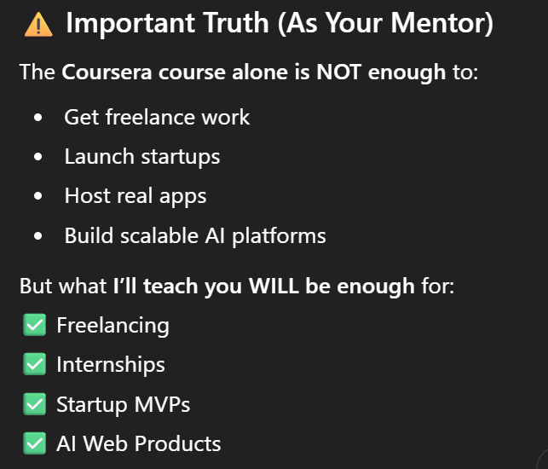
To open VSCODE using “current folder/file” , type:
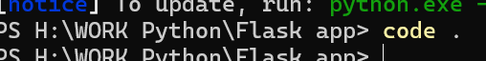

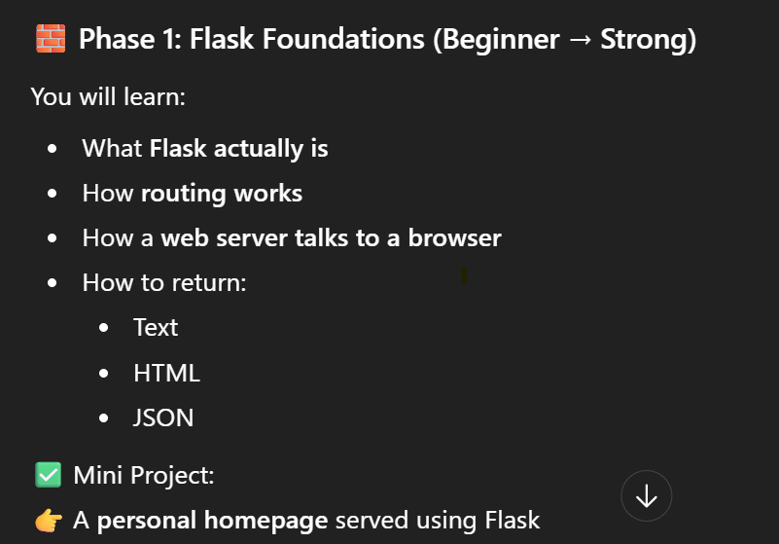

What is Flask?
It is a “web framework” built as a “python lib “ which connects python code with the browser. It makes code the “Server” (which can: RECEIVE requests, SEND response using HTTP).
In short:
This framework makes:
Backend A Browser connection
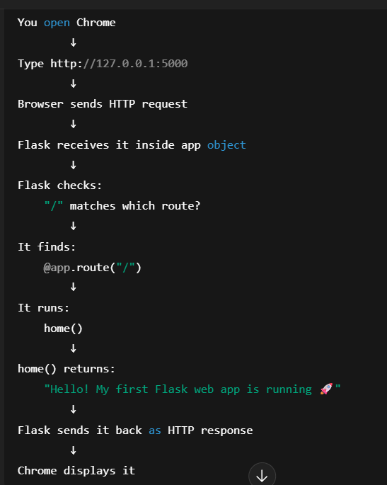
Framework v/s Library:
- Framework has a structure in which logic is placed, in library it never happens.
Ie: @app.index(“/”) has “response” logic , d = pd.Dataframe(…) its part of logic
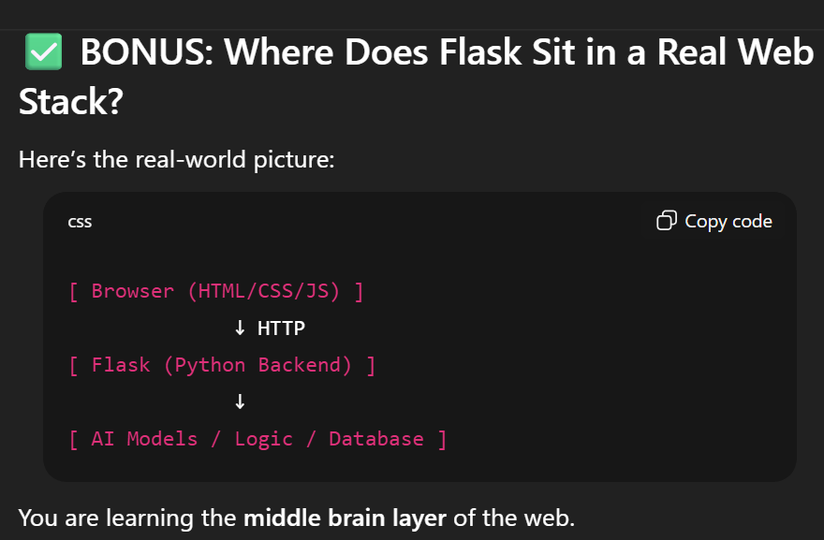

A route is “path of our page”
How flask looks for “route” in URL “ http://127.0.0.1:5000/about “ :
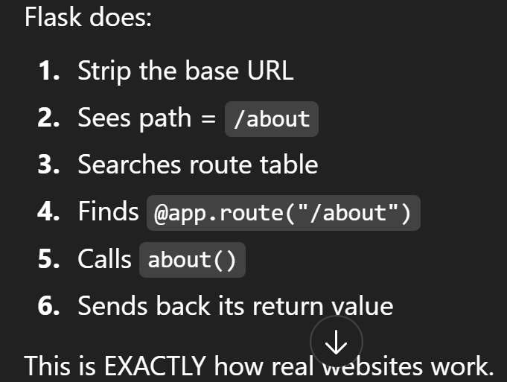

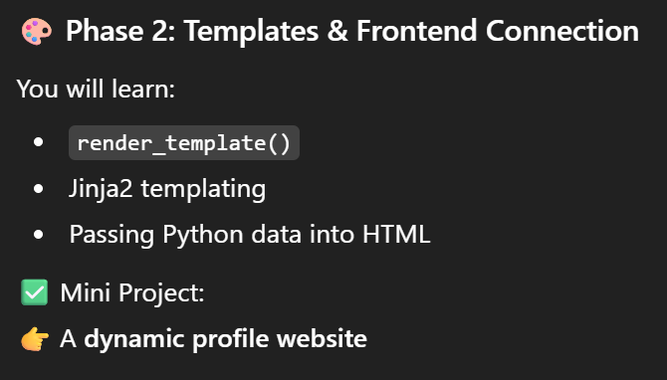
What does “render_template()” function do:
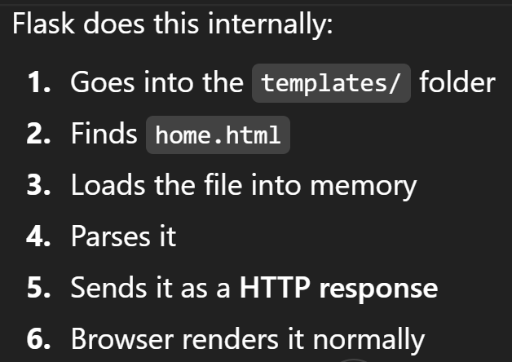
Sending data from Python to HTML templates (dynamic website):
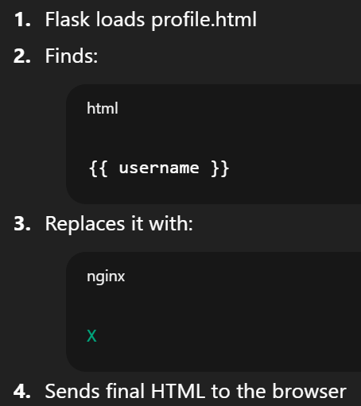
- We use: Jinja2 Templating (Flask’s template engine):
  - Jinja2 is the HTML logic processor used by Flask. Its syntax is:
    - {{ variable }} , {% if age >= 18 %} etc
  - For making dynamic web: Flask + Jinja2
  - Normally, HTML is dead/static:
  - When Flask loads values, Jinja2 injects them into HTML
- HTML is being filled dynamically .
- What “render_template()” doing is: SSR (Server-side rendering)
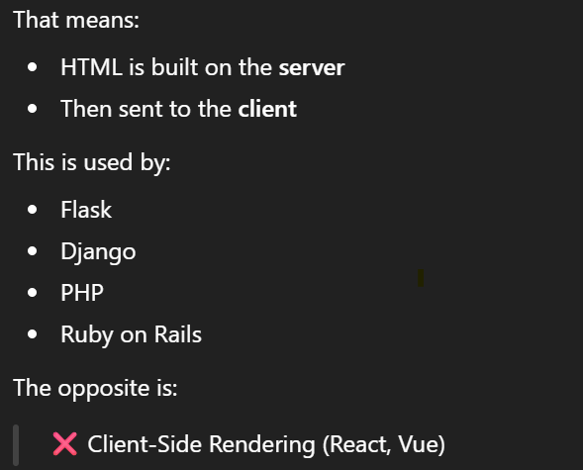

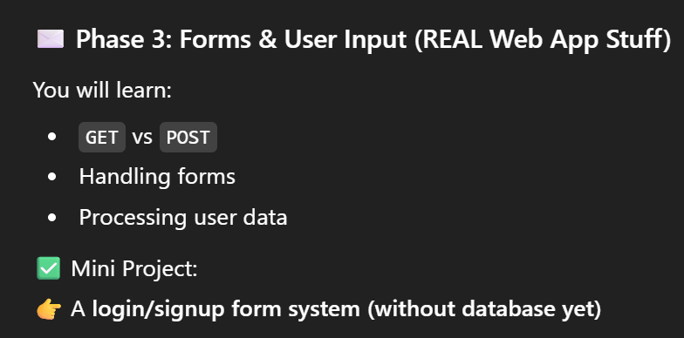
Ways of data passing:
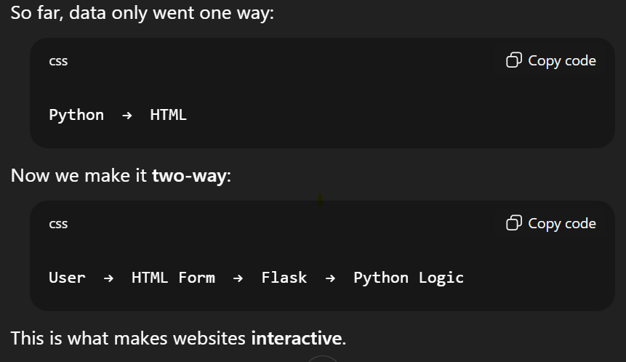
What is a Form?
A form is an HTML structure which:
- Collects user input
- Give it to Flask route
HTML ‘POST’ the ‘form’ to python logic:
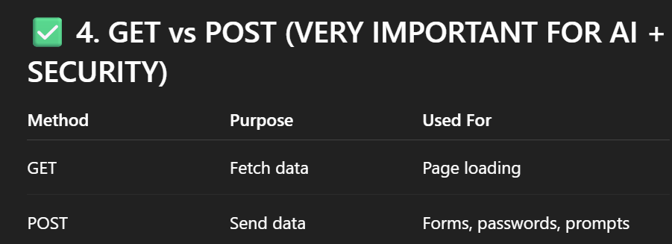

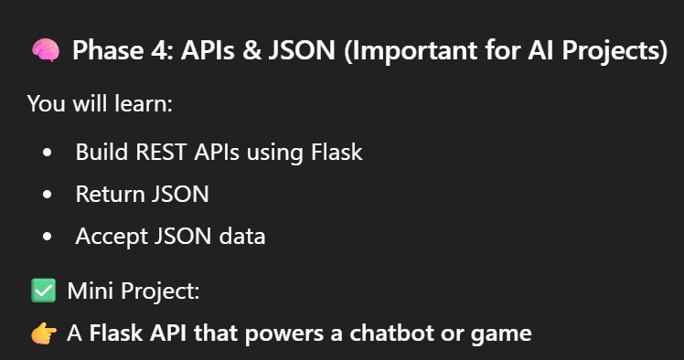
What is JSON? In simple words:
- “It is the language of internet”
- J S O N Javascript Object Notation . A Simple data format . Looks like dictionary
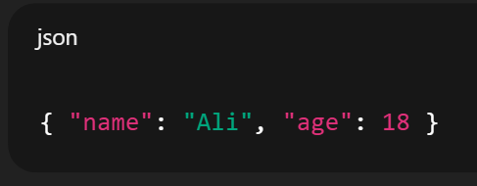
As it is:
easy to understand by humans , by machines and It is used by EVERY API ON EARTH!
(huggingface inference, AWS bedrock, Openai API, etc)
Whenever you give prompt to AI model, you are giving a JSON data to it through an API!
That’s why: JSON is important to understand

What is API ? in simple words:
- “An API is a way for two programs talk to each other”
Just like a waiter in a restaurant, a guard in a house.
- When you use ChatGPT , u use it’s ‘interface’:
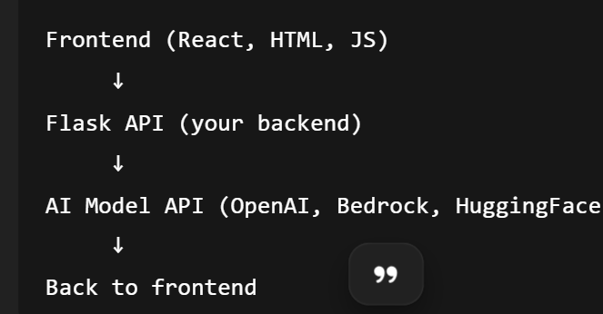
- APIs don’t use HTML. , They return JSON.
What is REST API? in simple words:
- “A REST API is a standard way of sending/receiving JSON data over the internet using URL.”
It uses:
• GET → fetch data
• POST → send data
• PUT → update data
• DELETE → delete data

For example What is AWS bedrock? In simple words:
- “It’s a giant collection of AI models you can call using their APIs” provided by Amazon.
AWS is a “Cloud” SaaS service of Amazon.
Creating a Flask API:
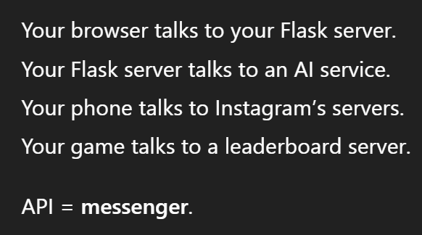
These communications happen over the internet using API calls.
JSON is simply the language used between your app and the AI model. Its standard for all ML & AI APIs
REST API is a web URL that you send data to (usually JSON) and get a response back (also JSON).
REST APIs are universal. For AI, REST APIs are the standard.
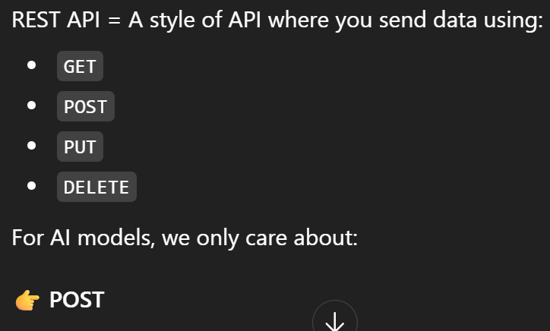
How to return JSON data using “jsonify”:
Create a new endpoint/route and return jsonify({ … }) in your endpoint function.
- Copy paste the URL and u can see your JSON data on Browser
Ie:
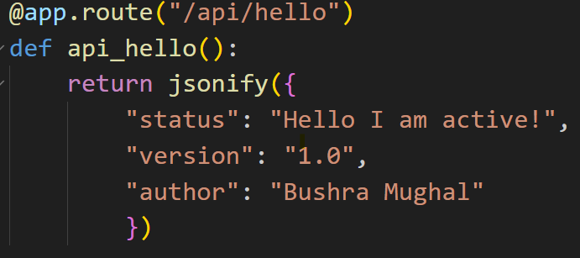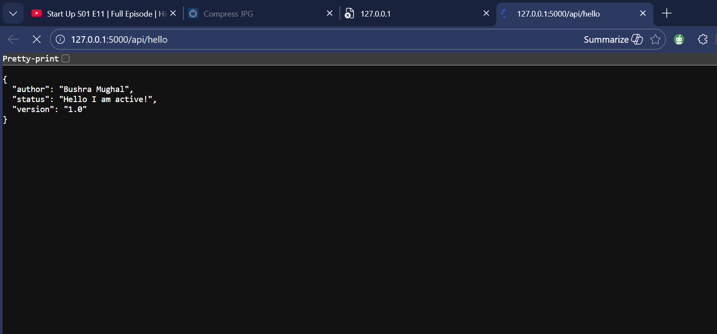
How to accept JSON data using:
This is exactly how AWS Bedrock / OpenAI APIs are consumed
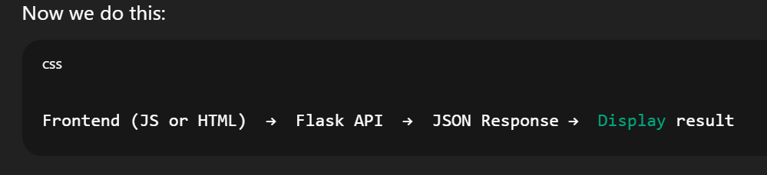
You receive JSON data from frontend.
Just “return” a “html file” using render_template():
- “chat.html” is:
- “POST” user_message to “/api/show_prompt” as a JSON data (just like we do in “HTML Forms input”)

